**WIDEBAND MILLIMETER-WAVE OFDM UPLINK WITH**

**HYBRID RECEIVING**

**ABSTRACT:**

The uplink transmission of millimeter-wave orthogonal frequency division multiplexing with a broad bandwidth and hybrid receiving is investigated in this research. The spectral efficiency of the system is examined by taking into account the spatial- and frequency-wideband effects in the channel model. The beam squint effect generated by wideband effects is visible in the analysis and simulation findings. Furthermore, the effects of bandwidth and subcarrier count on the beam squint effect are highlighted.

**Keywords**—Millimeter-wave (mm-wave), wideband, beamsquint, orthogonal frequency division multiplexing (OFDM), hybrid.

**EXISTING SYSTEM:**

Existing method deals with the problem of channel estimation in the presence of beam-squint effect, although the ML criterion suggests that coupling among different AoA/AoD must be exploited, the modification of the suboptimal strategy proposed achieves the same performance results as the proposed SW-OLS algorithm.

In existing method, an algorithm that approximates the optimal solution to the dictionary-constrained Maximum-Likelihood (ML) estimator for frequency-selective mm Wave channels considering frequency-dependent array responses. Further, a suboptimal channel estimation strategy to consider the beam squint effect as well. Channel estimation approaches are proposed to address the beam squint effect in wideband mm-wave systems.

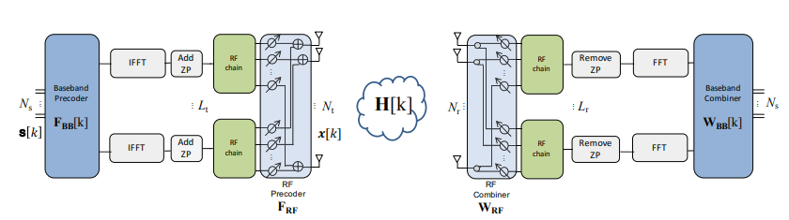

Fig: Illustration of the structure of a hybrid MIMO architecture, which include analog and digital precoders and combiners.

**DISADVANTAGES:**

* The spectral efficiency of the wideband mm-wave systems with hybrid receiving has not been analysed.
* Dual-wideband effects, i.e., the spatial- and frequency-wideband effects, have not been considered
* Not addressed about the beam squint effect in wideband mm-wave systems.

**PROPOSED METHOD:**

In proposed method, the spectral efficiency of wideband mm-wave orthogonal frequency division multiplexing (OFDM) uplink transmission with hybrid receiving is analysed. The base station (BS) is equipped with a large array and employs a hybrid receiving structure. The dual-wideband effects are considered in the channel model. By analyzing the norm of the beamspace channel, the spectral efficiency of the system is derived, which shows the deterioration caused by the beam squint effect. Moreover, the impacts of the bandwidth and the number of subcarriers on the beam squint effect are revealed by analyzing the spectral efficiency, which provide guidance for designing the system.

A mm-wave uplink system where one single-antenna UE transmits OFDM signals to the BS with M antennas. The BS antennas are connected to a phase shift network and $N_{RF}$

RF chains. In the digital processing unit, the signals are processed with matched filters

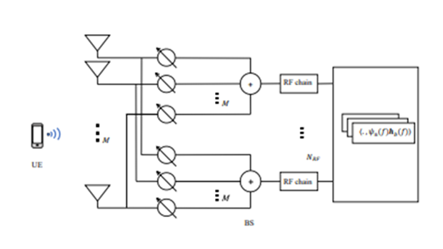  
Fig. A mm-wave uplink system

**Advantages:**

1. We analysed the spectral efficiency of wideband mm-wave OFDM systems with a large antenna array at the BS.
2. By increasing the number of subcarriers the beam squint effect can be alleviated.
3. By considering the spatial- and frequency-wideband effects in the channel model, the spectral efficiency of the system is analysed.

**Applications:**

1.Radio astronomy,

2.Remote sensing,

3. Automotive radars,

4. Military applications,

5. Imaging,

6. Security screening,

7. Telecommunications

**Software & Hardware Requirements:**

**Software:** Matlab R2018a.

**Hardware:**

**Operating Systems:**

• Windows 10

• Windows 7 Service Pack 1

• Windows Server 2019

• Windows Server 2016

**Processors:**

Minimum: Any Intel or AMD x86-64 processor

Recommended: Any Intel or AMD x86-64 processor with four logical cores and AVX2 instruction set support

**Disk:**

Minimum: 2.9 GB of HDD space for MATLAB only, 5-8 GB for a typical installation

Recommended: An SSD is recommended a full installation of all Math Works products may take up to 29 GB of disk space

**RAM:**

Minimum: 4 GB

Recommended: 8